

Minor Project

Fetching recent events related to the disaster which the image represents.

Supervisor Name : Dr Indu Chawla

Name : 1. Sankalp Agrawal 18103022

2. Shyam Agarwal 18103025

3. Ria Ahlawat 18803004

1. **Motivation behind the project**

Natural disasters cannot be prevented – but they can be detected, giving people precious time to get to safety. At present, natural disasters are identified using sensor such as seismic sensor, radar maps, vibration sensor, etc. Each of these sensors is highly specialized to the task at hand. Using computer vision we can augment existing sensors, thereby increasing the accuracy of natural disaster detectors and most importantly, allow people to take precautions, stay safe, and prevent/reduce the number of deaths and injuries that happen due these disasters.

Moreover, the model made by us can be deployed in satellites, CCTV cameras etc. Which will be very useful in identification of such disaster and take necessary steps as soon as possible.

**Problem Identification** :-

Our main problem was to collect the natural disaster images from google, then to train the model to fulfil our requirement without interfering the accuracy of the model. And at last we will also display the recent events regarding the identified disaster.

2. **Type of project**

Pure development project

4. **Overall design of project (diagram is welcome).**

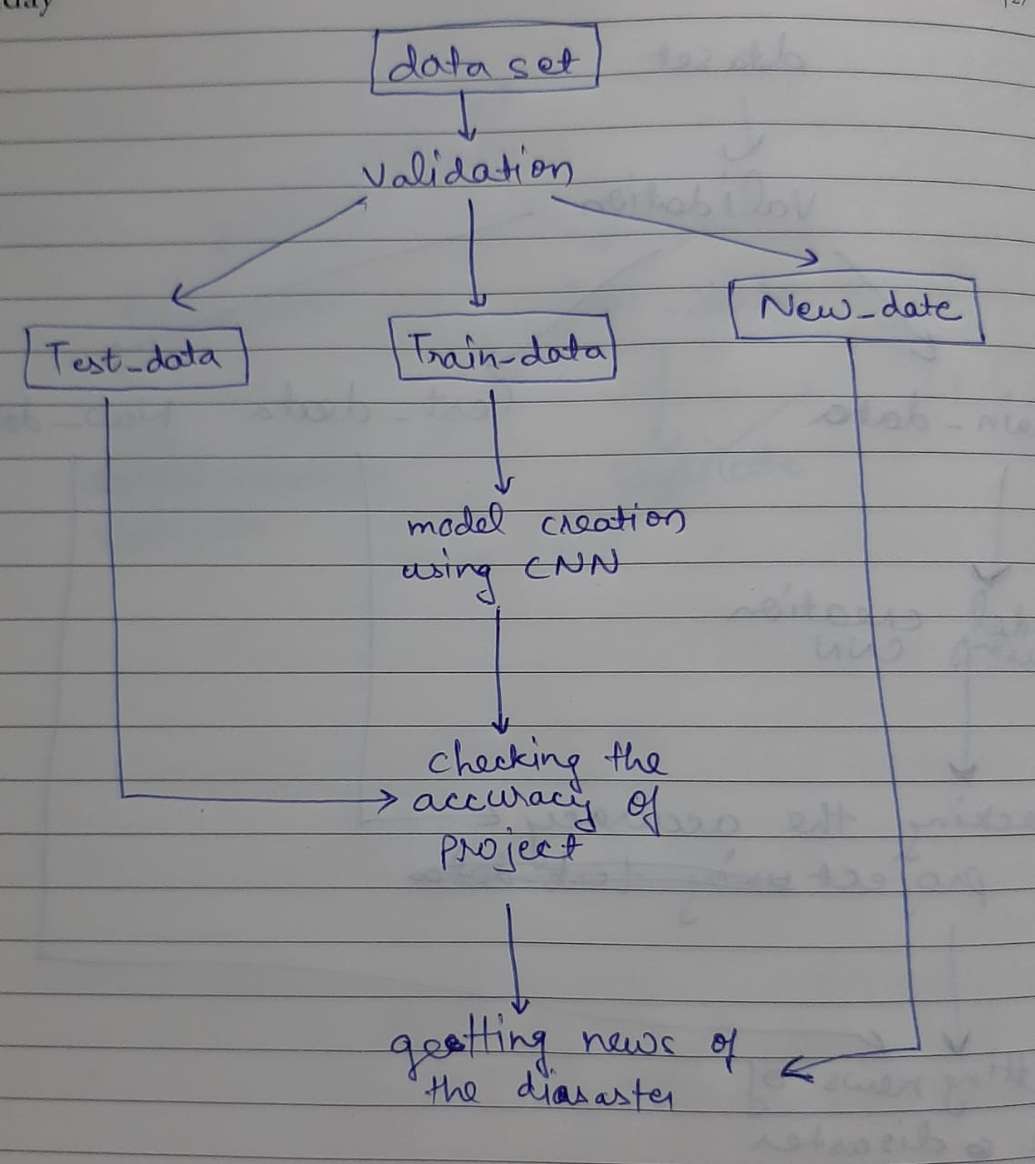

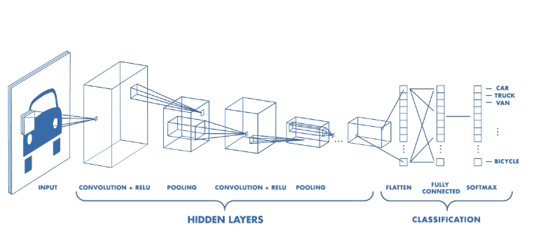

5. **Features build , language used**

We will identify the natural disaster namely earthquake, flood, wildfire, cyclone by image classification using **CNN(Convolutional Neural Networks)** with the help of keras library. And will show the recent news for the disaster regarding its recent update, consequences, and prevention techniques etc.

Language used is **python**.

6. **Some screen shots for usage of the projects.**

Earthquake Flood

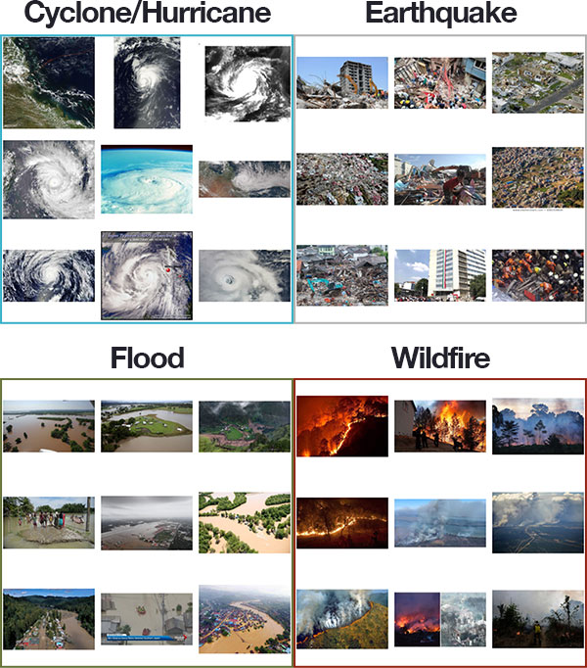

Wildfire Cyclone



**Reference:**

1 .L. Matikainen and H. Kaartinen, “Automatic detection of changes from laser scanner and aerial image data for updating building maps,” Matrix, vol. 35, pp. 434–439, 2004.

12 E. Sumer and F. V. Celebi, “Detection of Tsunami Induced Changes from High Resolution Satellite Imagery,” Ocean. 2006 - Asia Pacific, pp. 1–7, 2006.

3 B. Faiza, S. S. Yuhaniz, S. Z. M. Hashim, and a K. Kalema, “Detecting floods using an object based change detection approach,” Comput. Commun. Eng. (ICCCE), 2012 Int. Conf., no. July, pp. 44– 50, 2012.

4 D. Sulla-menashe, R. E. Kennedy, Z. Yang, J. Braaten, O. N. Krankina, and M. A. Friedl, “Remote Sensing of Environment Detecting forest disturbance in the Pacific Northwest from MODIS time series using temporal segmentation,” Remote Sens. Environ., vol. 151, pp. 114–123, 2014.

5 L. Gueguen and R. Hamid, “Large-scale damage detection using satellite imagery,” 2015 IEEE Conf. Comput. Vis. Pattern Recognit., pp. 1321–1328, 2015.

6 R. Kovordányi and C. Roy, “Cyclone track forecasting based on satellite images using artificial neural networks,” ISPRS J. Photogramm. Remote Sens., vol. 64, pp. 513–521, 2009.

7 A. J. Cooner, Y. Shao, and J. B. Campbell, “Detection of Urban Damage Using Remote Sensing and Machine Learning Algorithms : Revisiting the 2010 Haiti Earthquake,” Remote Sens., no. Ml, 2016.

8 J. Tu, H. Sui, W. Feng, and Z. Song, “Automatic Building Damage Detection Method Using High-Resolution Remote Sensing Images and 3D Gis Model,” ISPRS Ann. Photogramm. Remote Sens. Spat. Inf. Sci., vol. III-8, no. July, pp. 43–50, 2016.